**ASSIGNMENT 3**

**20IM10009**

**DHUWARE CHAITANYA RAKESH**

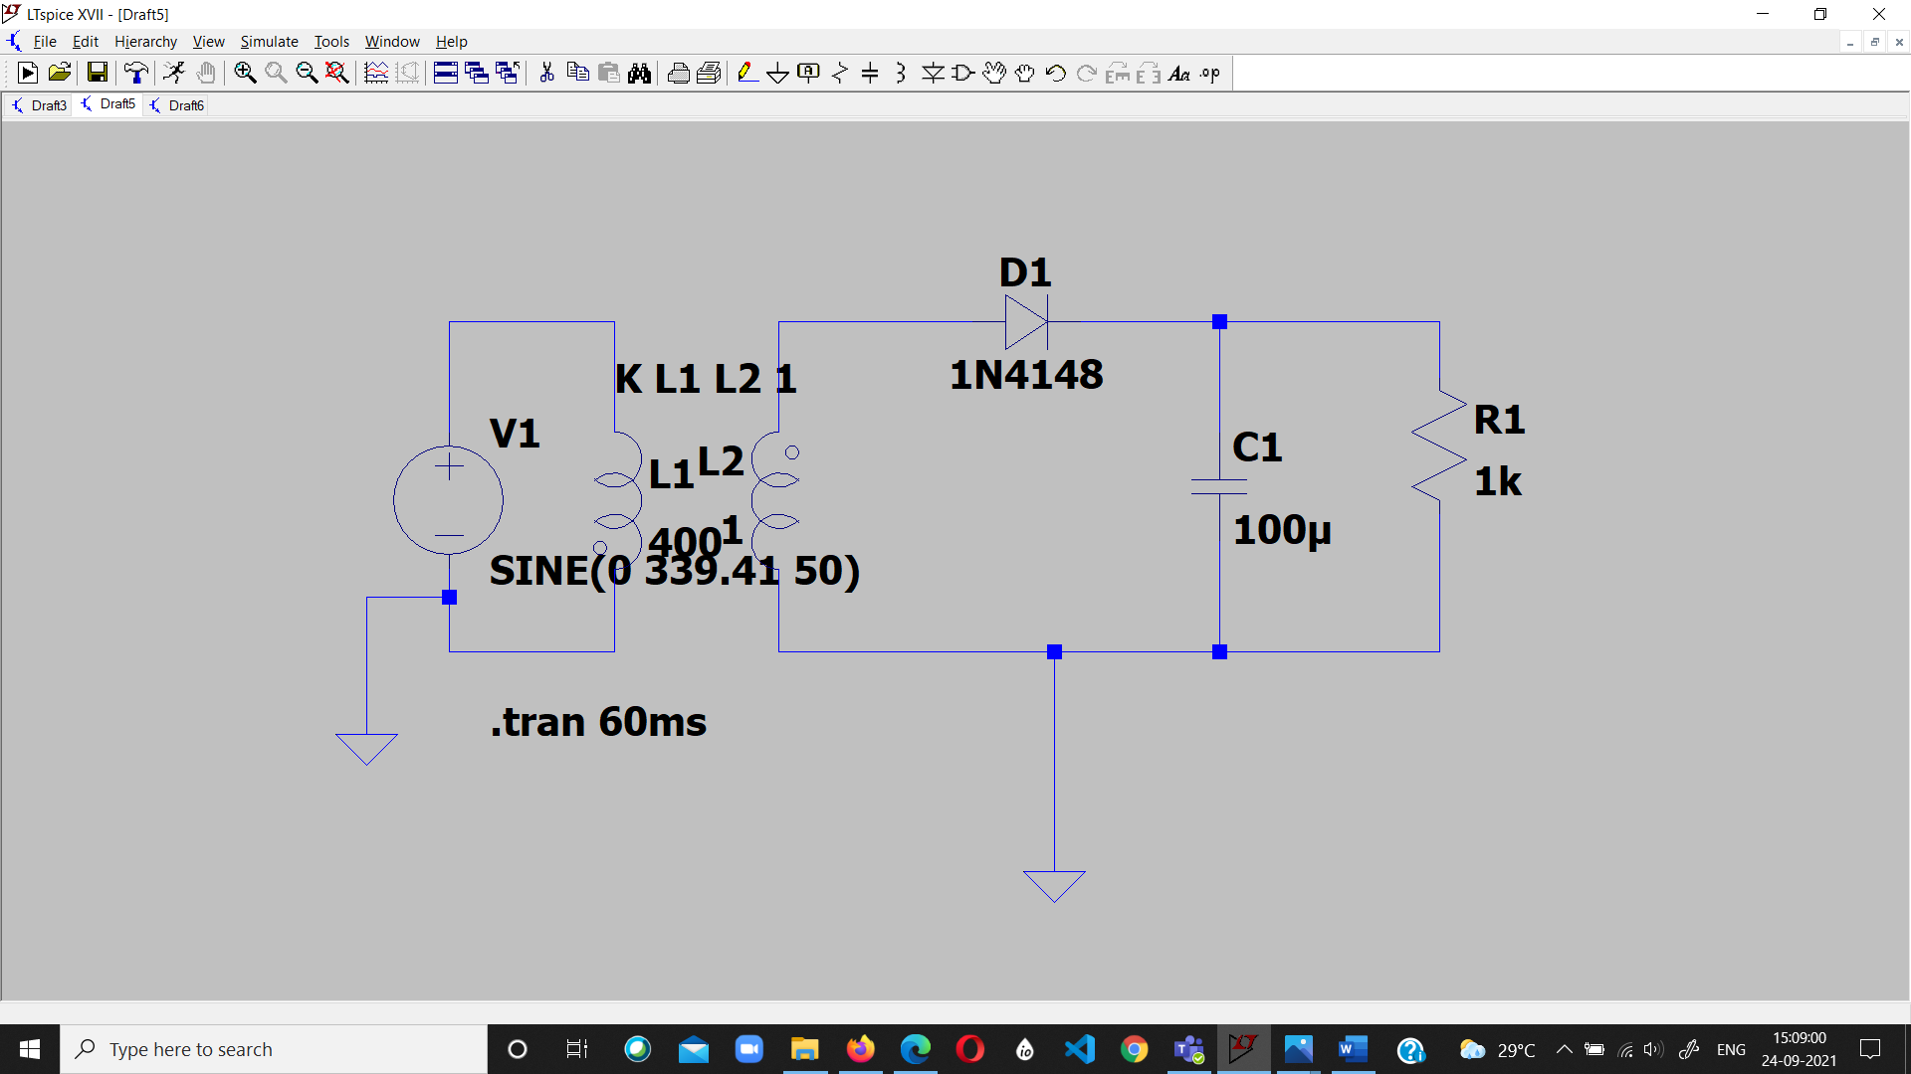

Half Wave Rectifier with Capacitive Filter

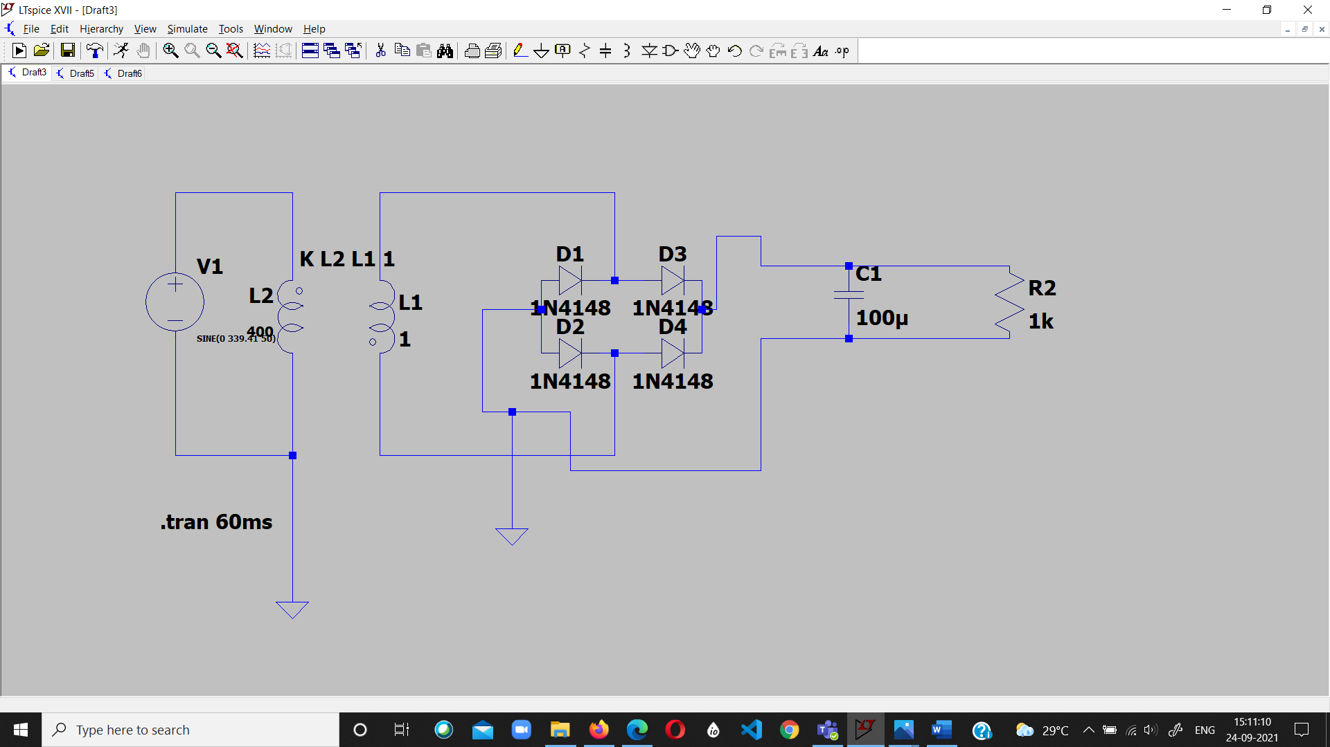

Bridge Rectifier with Capacitive Filter

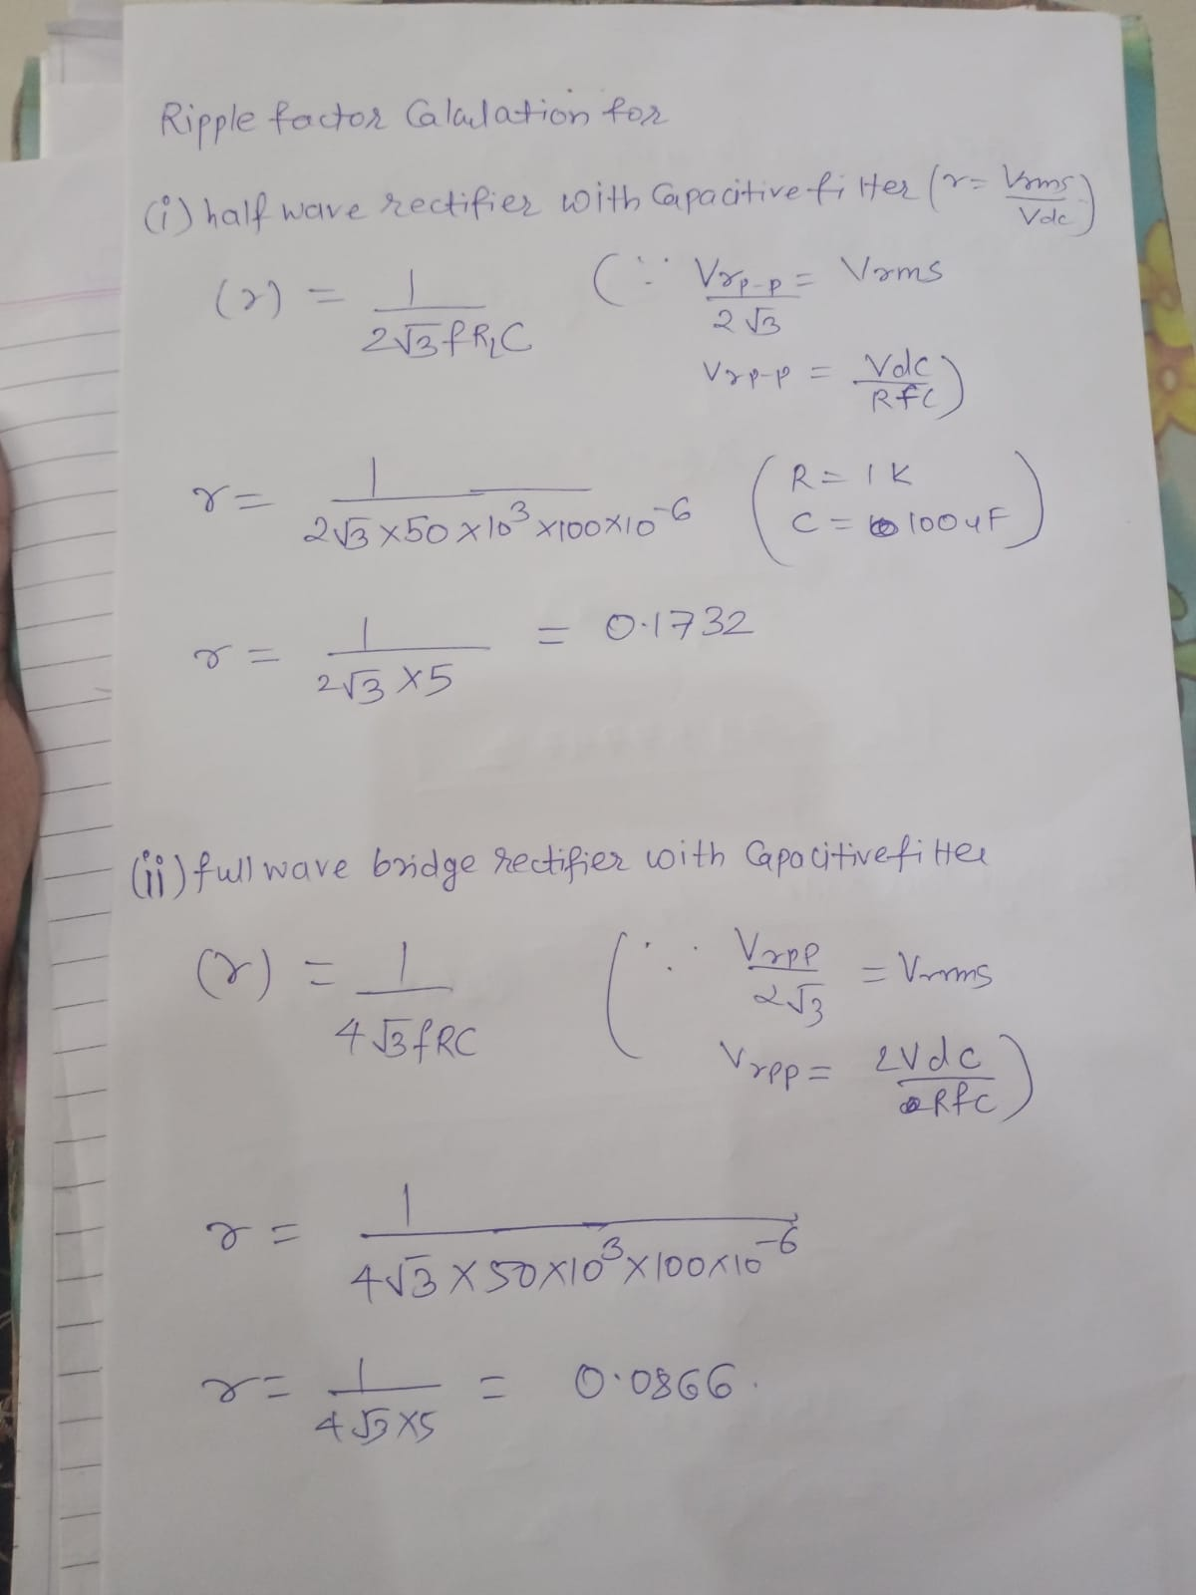

**RIPPLE FACTOR FOR HALF WAVE RECTIFIER WITHOUT CAPACITOR FILTER**

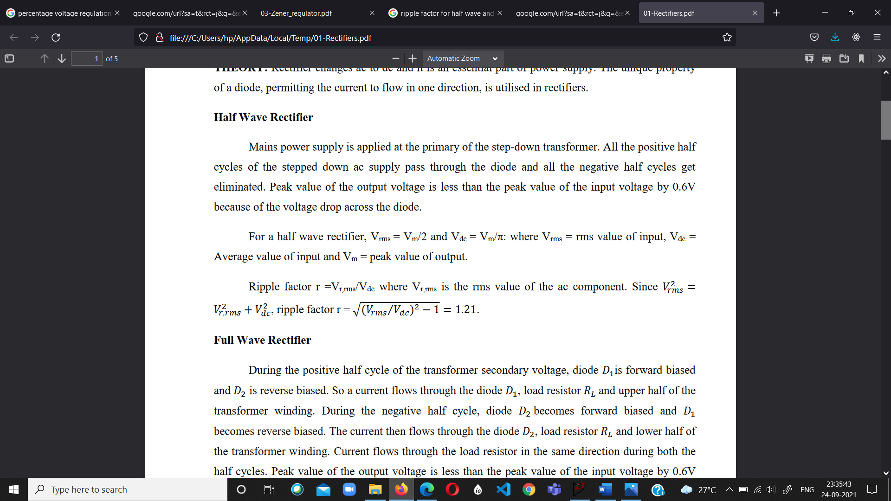

**RIPPLE FACTOR FOR FULL WAVE RECTIFIER WITHOUT CAPACITOR FILTER**

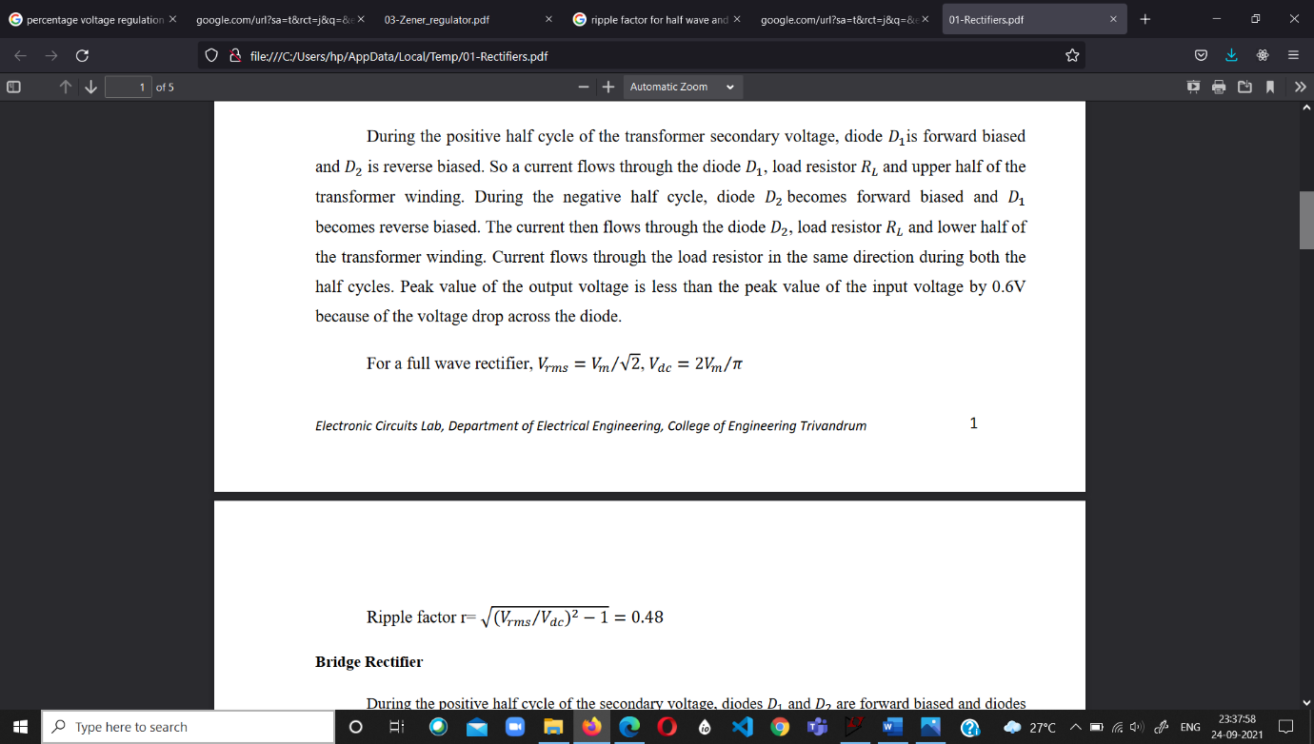



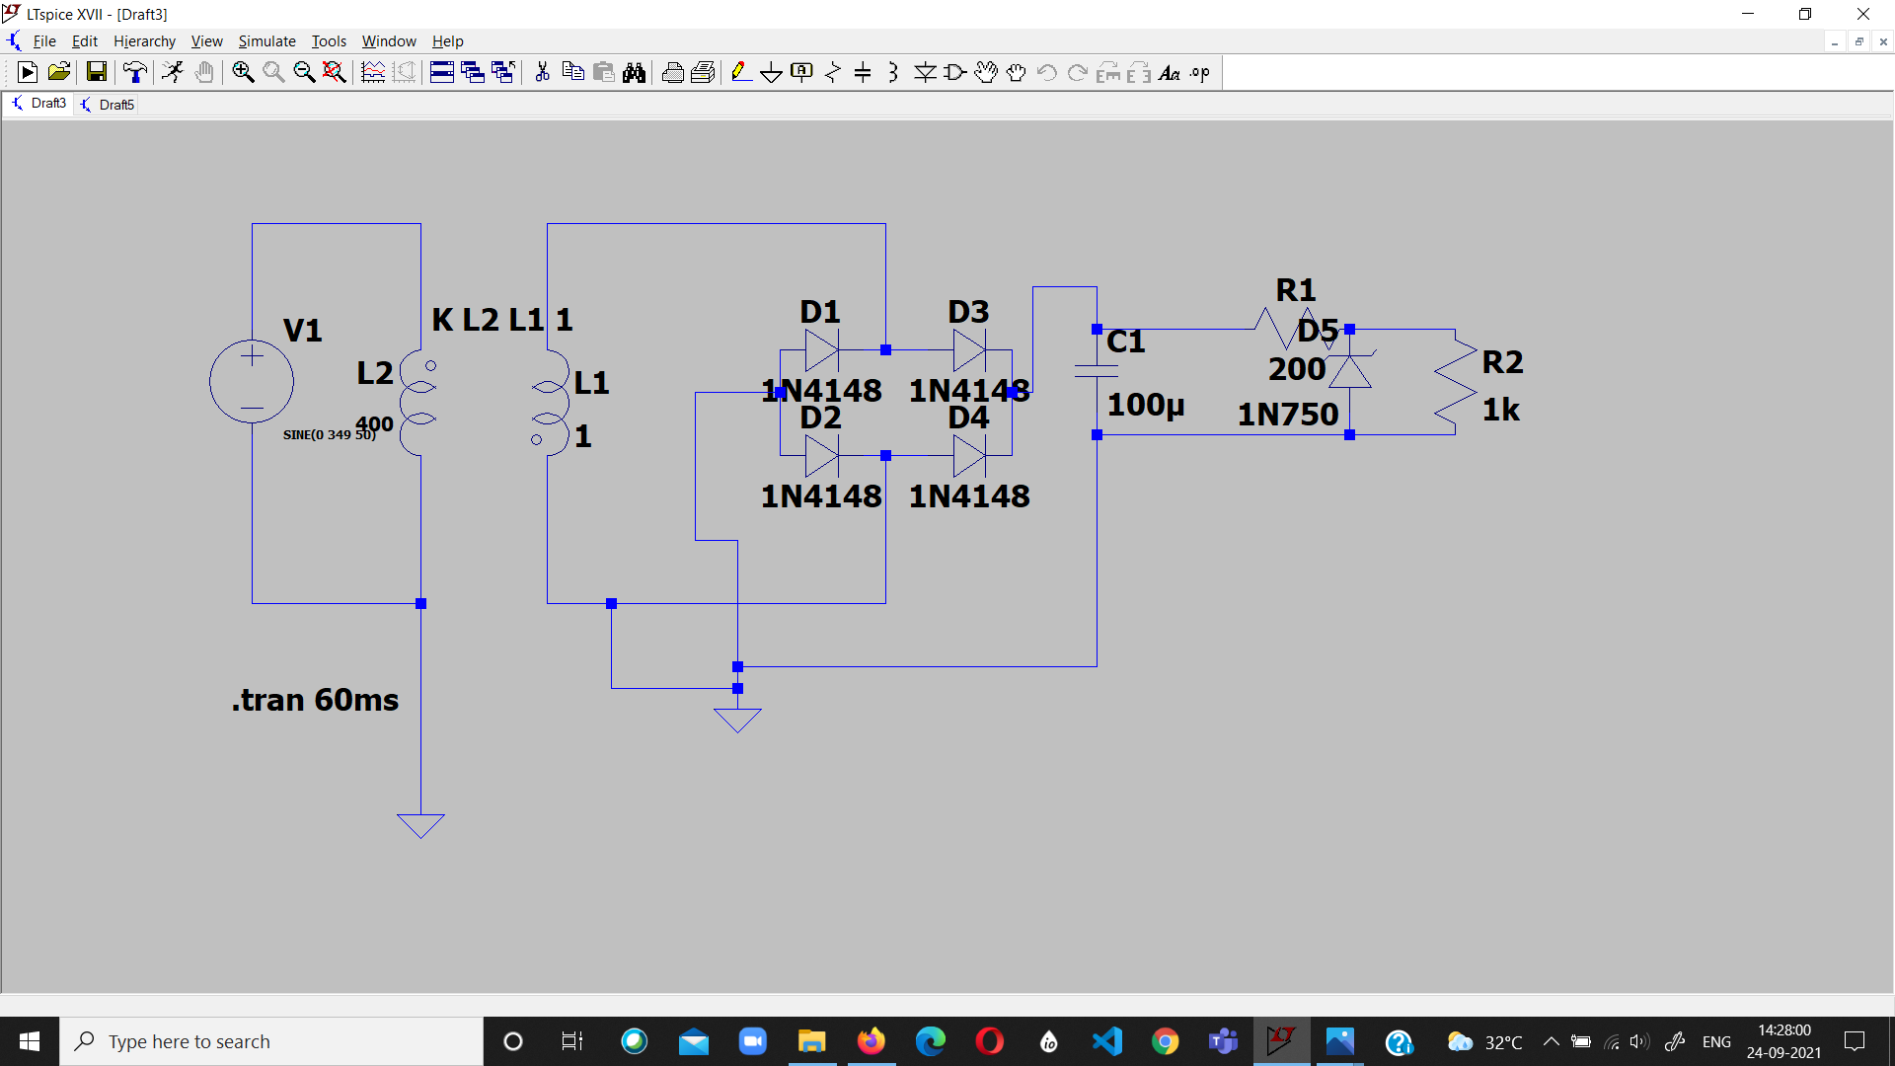

ZENER DIODE CIRCUIT

Voltage Regulation Efficiency

V(no load) = 4.876

V(load) = 4.54

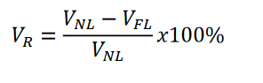

Efficiency = (4.856-4.54)/4.856

= 6.5478 %